Software Design Document
<Cheating Surveillance System>



Submitted by
<Muhammad Waqar (F22BINFT1M01034)>

Submitted to
<Dr Muzamil Sahb>

Department of Information Technology
Faculty of Computing
The Islamia University of Bahawalpur

Summery
This Software Design Document (SDD) outlines the design and architecture of the Cheating Surveillance System, a real-time monitoring solution aimed at detecting and preventing cheating during examinations. The system uses computer vision (OpenCV) and a Python-based backend to analyze live video feeds, detect suspicious activities, and alert invigilators. This document details the application architecture, data models, user interface design, and implementation considerations based on the requirements specified in the SRS.

Table of Content

1. Application Architecture
1.1. System Architecture Overview
1.2. MVC Pattern Implementation
1.3. Components Description
1.4. External Libraries & APIs
1.5. UML Diagrams
1.6. Coding Conventions

2. Data Model Schema
2.1. Database Conceptual Schema
2.2. Entity Descriptions
2.3. ER Diagram

3. User Interface
3.1. Design Philosophy
3.2. Screen List & Descriptions
3.3. Controls & Input Constraints

- Application Architecture

1.1. System Architecture Overview

The system follows a Client-Server Architecture with a web-based frontend and a Python backend. It is designed to process real-time video streams from CCTV/webcams, apply computer vision algorithms for cheating detection, and provide a dashboard for monitoring and alerts.

1.2. MVC Pattern Implementation

The backend follows the Model-View-Controller (MVC) pattern:

- Model: Represents data entities (User, Alert, VideoEvidence).

- View: Frontend pages (HTML/CSS/JS) that display data.

- Controller: Handles business logic, processes video feeds, and manages user requests.

1.3. Components Description

Proposed Models:

- User: Stores admin/invigilator details.

- Camera: Stores camera configurations and locations.

- Alert: Logs detected cheating incidents.

- VideoEvidence: Stores recorded video clips of incidents.

Proposed Controllers:

- AuthController: Handles user signup and login (FR001, FR002).

- MonitoringController: Manages live video streaming (FR003).

- DetectionController: Runs cheating detection algorithms (FR004).

- AlertController: Generates and manages alerts (FR005).

- EvidenceController: Handles video storage and retrieval (FR006).

Proposed Views:

- LoginView, DashboardView, LiveFeedView, AlertsView, EvidenceView.

1.4. External Libraries & APIs

- OpenCV: For real-time video processing and motion detection.

- Flask/Django: Python web framework for backend.

- MySQL Connector: Database connectivity.

- JavaScript (Frontend): For live video display and alert notifications.

1.5. UML Diagrams

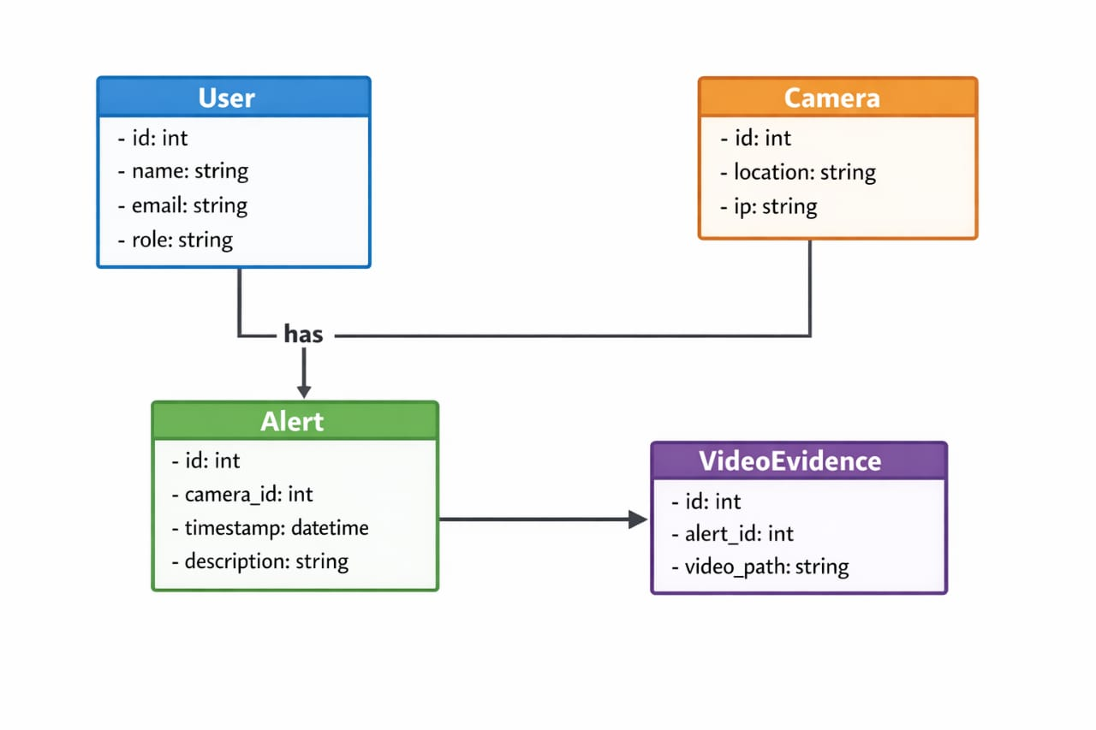

Sequence Diagram – Cheating Detection Flow:

Invigilator -> System: Start Monitoring

System -> Camera: Capture Video Feed

Camera -> System: Stream Frames

System -> DetectionController: Analyze Frame

DetectionController -> AlertController: If Suspicious Activity

AlertController -> Invigilator: Show Alert

AlertController -> EvidenceController: Save Video Clip

1.6. Coding Conventions

- Backend (Python): PEP 8 style guide.

- Frontend (HTML/CSS/JS): CamelCase for JS, BEM for CSS.

- Database: Snake_case for table and column names.

- Git: Feature-branch workflow with meaningful commit messages.

- Data Model Schema

2.1. Database Conceptual Schema

The system uses MySQL with the following tables:

- users

- cameras

- alerts

- video_evidence

2.2. Entity Descriptions

Table: users

| Field | Type | Description |

|-------------|-------------|---------------------------------|

| id | INT (PK) | Unique user ID |

| name | VARCHAR(50) | Full name |

| email | VARCHAR(100)| Email address |

| password | VARCHAR(255)| Hashed password |

| role | ENUM | Admin / Invigilator |

| created_at | DATETIME | Account creation timestamp |

Table: cameras

| Field | Type | Description |

|-------------|-------------|---------------------------------|

| id | INT (PK) | Camera ID |

| location | VARCHAR(100)| Exam hall location |

| ip_address | VARCHAR(15) | Camera IP address |

| status | ENUM | Active / Inactive |

Table: alerts

| Field | Type | Description |

|-------------|-------------|---------------------------------|

| id | INT (PK) | Alert ID |

| camera_id | INT (FK) | Reference to cameras table |

| timestamp | DATETIME | Time of detection |

| description | TEXT | Type of cheating detected |

| severity | ENUM | Low / Medium / High |

Table: video_evidence

| Field | Type | Description |

|-------------|-------------|---------------------------------|

| id | INT (PK) | Evidence ID |

| alert_id | INT (FK) | Reference to alerts table |

| video_path | VARCHAR(255)| Path to stored video clip |

| created_at | DATETIME | Timestamp of storage |

2.3. ER Diagram

users (1) --- (0..) alerts

cameras (1) --- (0..) alerts

alerts (1) --- (1) video_evidence

- User Interface
3.1. Design Philosophy
- Color Scheme: Professional blue (#2A3B8F) and white for clarity.
aaaa- Font: Roboto (clean, readable).
- Responsive Design: Works on desktop and tablet screens.
- Minimalist Layout: Focus on live feed and alerts.

3.2. Screen List & Descriptions

1. Login Screen
- Controls: Email input, Password input, Login button.
- Input Constraints: Email format validation, password length ≥ 8.

2. Dashboard
- Controls: Navigation menu, Live feed preview, Alert notifications.
- Data Display: Active cameras, recent alerts count.

3. Live Monitoring Screen
- Controls: Video feed panel, camera selector, pause/resume button.
- Data Display: Real-time video stream with overlaid detection boxes.

4. Alerts Screen
- Controls: Alert list, filter by severity, acknowledge button.
- Data Display: Timestamp, camera location, description.

5. Evidence Archive
- Controls: Search bar, date filter, video player.
- Data Display: List of stored video clips with metadata.
3.3. Controls & Input Constraints
- Textboxe : Max length enforced, input sanitization.
- Dropdowns: Predefined options (e.g., role selection).
- Buttons: Clear visual feedback on click.
- Video Controls: Play, pause, download evidence.

